**Table of Contents**

**Program Information**

**Welcome 3-4**

**Overview 5**

**Social Media 5**

**Mission and Vision 6**

**Your Site Contact Information 7**

**Program Policies**

**Suggestions for Parents 8**

**Positive Guidance 10**

**Suspension/Expulsion Policy 11**

**Child Abuse and Neglect 16**

**Emergency Preparedness 16**

**Special Occasions**

**Holiday, and Field Trips 17**

**Complaint and Grievance 18**

**Nutrition and Health Info**

**Nutrition/Meal Services 12**

**Health/Safety Services 13**

**Short Term Exclusion/ Inclusion Policy 14**

**COVID-19 15**

**Medication Policy 15**

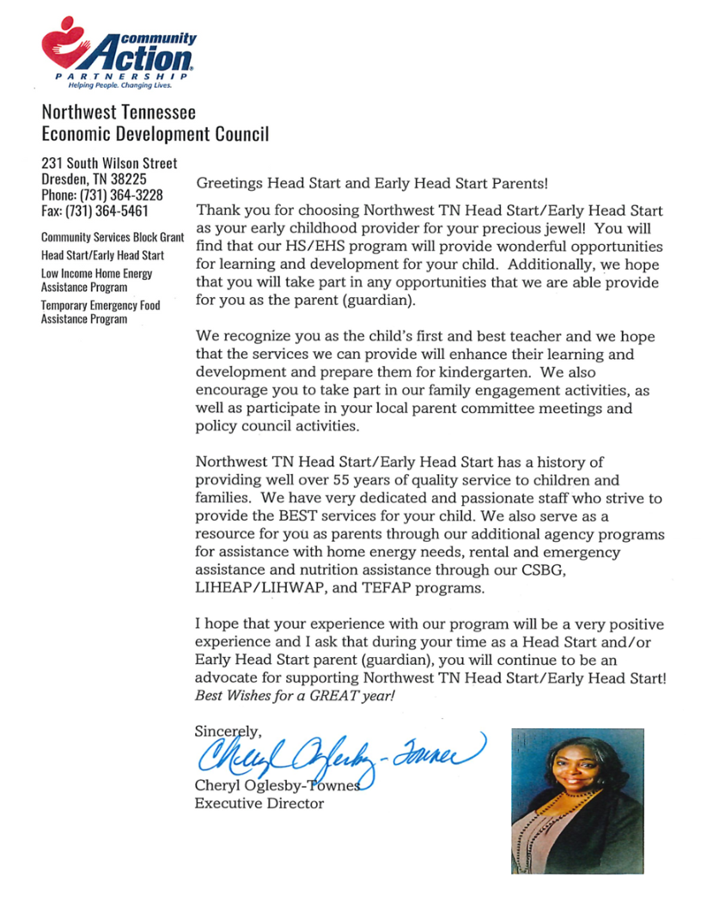

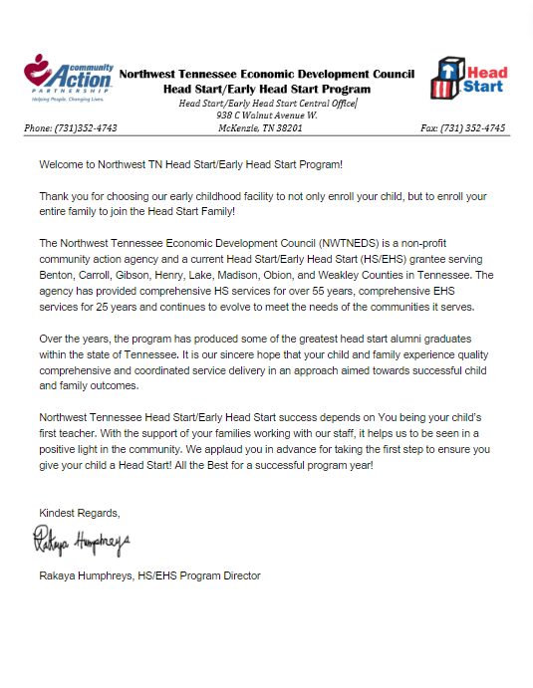

**About the Program**

**Program Information**

The Northwest Tennessee EconomicDevelopment Council is a non-profit community action agency and a current Head Start/Early Head Start (HS/EHS) grantee serving 8 counties. The agency has provided comprehensive HS services for over 59 years, comprehensive EHS services for 30 years and continues to evolve to meet the needs of the communities it serves.

Our Head Start program provides center-based services to 739 children. Our Early Head Start (EHS) pregnant moms, infant and toddler program provides center-based services to 132 children.

Our centers are located within 8 counties, Benton, Carroll, Gibson, Henry, Lake, Madison, Obion, and Weakley Counties in Tennessee.

For more information regarding locations and program services, please visit www.nwcommunityaction.org or call Northwest Tennessee Head start Program at (731)352-4743.

**Social Media**

For news, updates and information follow along on Twitter (X), Instagram, and Facebook.

**Program Management**

The Northwest Tennessee Head Start Program has a strong governance structure. Parents/guardians are encouraged to participate in policy making decisions. Governance includes participation in the Head Start Policy Council. The Head Start Policy Council members are current Head Start or EHS parents/guardians. In addition, all parents/guardians of currently enrolled children are eligible to participate in the local parent committee meetings. These committees play an important role in ensuring program decisions are made with parent/guardian input. Talk to the Family Advocate to learn more about participating in this process. Every parent/guardian’s voice is important.

**Philosophy**

The Northwest Tennessee Head Start / Early Head Start Program firmly believes that the lives of young children and their families can be enriched and strengthened by the quality of the services provided to them. It is based on a firm and proven belief that "Working together we can make a difference."

The role of the agency is to act as an advocate and service provider for children and families and

to fulfill this role through partnerships with parents and agencies that are grounded in mutual

goals, trust, and accomplishments.

**Mission**

Helping People, Changing Lives in our community through education, partnerships, and delivery of quality services in Northwest Tennessee.

**Vision**

Hand in hand, working together we are dedicated to helping people help themselves and each other to make a difference in our communities.

**Motto**

Working Together We Make A Difference.

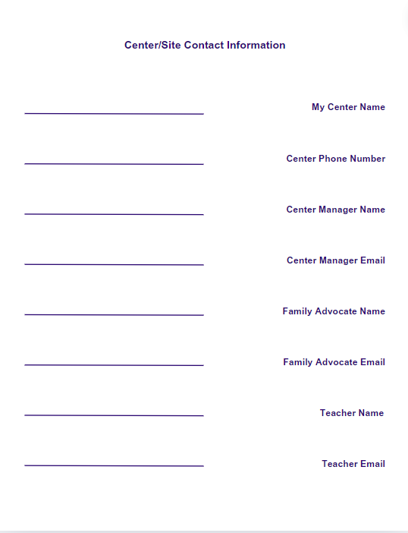

Program Information

Program Policies and Information

**Guidelines and Suggestions for Parents**

These easy-to-follow guidelines were written to make your time in Head Start a pleasant and enjoyable experience.

* Physical violence, horseplay, cursing or loud arguments or conversations are not allowed.
* You cannot spank your child at the center.
* Department of Children’s Services workers can look at records and interview a child at the center without notifying the parent.
* Siblings cannot be brought to the center or on a field trip when you volunteer. Siblings are allowed at the center for family engagement activities.
* Parents must sign their child in and out at the center or bus stop.
* Parents must not bring food or drinks into the center or classroom.
* Do not let your child bring food or toys to the center or on the bus.
* Remember Head Start buildings, buses, and grounds are smoke, drug, and alcohol free.
* Take part in the “Readers are Leaders” program and read to your child. Each center has a Lending Library; the number of books that can be checked out will be determined by your specific center.
* The Customer/Community Complaint and Grievance procedure will be posted on the parent bulletin board, and it is also included in this

handbook. Your family advocate or center manager can explain the procedure to you.

* Your family advocate will give you a school calendar for your child’s center at open house/orientation.
* Your center manager will give the Parent Committee bids from photographers. The parents will then vote on a photographer and a picture package of their choice. Parents will vote on when children’s pictures are taken during the program year. Pictures of Pre-K/Head Start students will be determined by the school system.

* The Center Manager or Area Manager will collect money from parents and give a written receipt of the total collected. Center Staff will submit picture money to the photographer.

Program Policies and Information

**Guidelines and Suggestions for Parents Continued**

* Send a complete change of clothes for your child and label each item.
* Children are to arrive “dressed for play.” Please do not bring your child in their pajamas unless “pajama day” is a planned event. In order to be a good example for your child, please dress appropriately during pick up and drop off times. Dress your child in comfortable, washable play clothes and shoes suitable for running and climbing on the playground. Flip-flops are not a good shoe choice for outdoor play.
* Children wearing large dangling earrings or long necklaces could get hurt so please refrain from sending them in these.
* The Chronic Absenteeism and Late Policies are available at your center and are included in this handbook as well.
* Your family advocate or center manager will review these policies with you.
* The Release of Child Policy will be posted on the parent bulletin board and is included in this handbook as well. Your family advocate or center manager will discuss the policy with you.
* If a family need arises, your child or children can be signed out prior to dismissal.
* It is not necessary that you purchase anything for your child to attend Head Start/Early Head Start. All supplies are provided by the program such as mats, crayons, and any other educational items.

Program Policies and Information

**Positive Guidance**

We want children to be successful in Head Start and be excited to come to the center and learn. Your child’s teachers will use the following ways to discipline and direct children:

* Be positive and patient with children.
* Bend down to their level to let children know they are interested and care about them.
* Praise children for good behavior and encourage success.
* Use positive terms when speaking to children. For example, if a child is running in the classroom, a teacher will tell him or her “we walk inside and run outside.”
* Give children jobs as helpers to learn responsibilities and independence.
* Use *(CSEFEL)* *Center on the Social Emotional Foundations of Early Learning* as a resource to teach children about feelings, how to resolve problems, and how to calm down.

* Redirect children when needed and review the classroom rules every day.
* Help children develop self-confidence and self-control through consistent routines and classroom rules

Program Policies and Information

**Suspension/Expulsion Policy**

Northwest Tennessee Head Start and Early Head Start cannot expel or un-enroll any child from our Head Start or Early Head Start program due to the child’s behavior. A temporary suspension of a child for persistent and challenging behaviors will be severely

limited and implemented as a last resort in extraordinary circumstances where there is a serious safety threat that cannot be reduced or eliminated by the provision of reasonable modifications. This determination will not be made prior to:

* Engaging a mental health consultant
* Collaborating with the child’s parents/caregivers
* Providing reasonable modification

* Identifying and accessing community resources, specialists, and early intervention providers.

If a temporary suspension is deemed necessary, Northwest Tennessee Head Start/Early Head Start will support the child’s return to full services as quickly as possible while ensuring child safety by continuing to engage with parents and the mental health consultant, continuing to utilize identified community resources, providing home visits, and making a determination for an IDEA referral. A written plan will be developed to document the action steps and support needed to promote the child’s successful return to full services.

In the event that child’s behavior continues to present a serious safety threat to the child or the other children in the classroom and all parties determine that the Head Start/Early Head Start program is not the appropriate place, we will comply with IDEA and the Rehabilitation Act, work with appropriate agencies, consultants and the child’s family to determine best placement and assist in facilitating the transition for the child to the most appropriate placement.

Nutrition & Health Information

**Nutrition and Meal Service**

Nutrition guidelines and best practices are listed below:

* Child and Adult Care Food Program (CACFP) approved meal patterns are used for meals.
* A Registered Dietician provides menus for all Head Start kitchens.
* Children, teaching staff, and volunteers eat together, sharing the same menu.
* Cultural, ethnic, and new foods are included on menus.
* A copy of the daily menu is given to parents monthly.
* Each child receives a nutrition evaluation in addition to height and weight assessment.
* Head Start/Early Head Start provides all meals. Due to USDA guidelines, no food (such as breakfast or lunch) can be brought into the center. All food is prepared on-site to meet the nutritional services guidelines.
* Parents are given the opportunity to make menu suggestions.

A registered dietician consultant will work closely with you and your child if he or she is overweight, underweight or has other nutritional needs. Parents have the right to deny this service.

**Substitutions or meal modifications that are nutritionally equivalent to the meal pattern can be made for children with food allergies or special dietary needs. However, a written statement signed by a medical professional is required for substitutions or meal modification that are not nutritionally equivalent to the meal pattern.**

**CONTACT INFORMATION:**

If you have questions about CACFP,

please contact one of the following:

Sponsoring organization/center

State Agency:

615-313-4749

Child and Adult Care Services

TN Department of Human Services

505 Deadrick Street, 15th Floor

Nashville, TN 37243-1403

Nutrition & Health Information

**Health and Safety Services**

Your child must receive the following screenings, examinations, and services:

* Physical
* Dental
* Immunizations
* Vision
* Speech and language
* Hearing
* Lead screening
* Follow-up medical and dental treatment, if needed
* Nutrition assessment and follow-up services
* Social – Emotional Screening
* Developmental Screening

You will be responsible for:

* Taking your child for a physical examination and dental examination
* Taking your child for follow-up medical and dental treatment
* Ensuring immunizations are provided on a Tennessee Department of Health Certificate of Immunization Form
* Asking your family advocate for help to make an appointment.
* Transporting your child by vehicle to and from the center in a car seat.

The safety and well-being of your child is important to us. We will work in partnership with you to protect and nurture your child.

Nutrition & Health Information

**Short Term Exclusion/Inclusion Policy**

An infectious illness or disease is any condition that can be transferred from one person to another person. If a child is identified with an infectious illness or disease, a designated staff member will determine whether the child’s illness meets the following criteria for temporary exclusion:

* Shows signs or symptoms of possible severe illness (i.e., lethargy/lack of responsiveness, irritability, persistent crying, dry cough/uncontrolled coughing, shortness of breath/difficulty breathing and a quick spreading rash)
* **Fever**: 100.4 degree or above
* **Vomiting**: More than two times in the previous 24 hours, unless vomiting is determined to be caused by a non-infectious condition and the child remains adequately hydrated
* **Diarrhea**: When stool cannot be contained in the diaper or causes soiled clothing for toilet trained children
* **Head lice/Scabies**: Treatment may be delayed until the end of the day; must have proof of treatment prior to readmission
* **Rash**: With fever or behavior changes, until a primary care provider has determined the illness is not an infectious disease
* **Impetigo**: Treatment may be delayed until the end of the day; must be treated according to a licensed medical professional’s instruction prior to readmission
* **Strep**: Must be treated according to a license medical professional’s instruction prior to readmission
* **Active Tuberculosis**: Until health care provider states child can return
* **Chickenpox**: Until all sores are dried and crusted
* **Rubella**: Until six days after the rash appears
* **Pertussis**: Until five days of appropriate antibiotic treatment.
* **Mumps**: Until five days after onset parotid gland swelling
* **Measles**: Until four days after onset of rash
* **Mouth sores**: With drooling unless health care provider states the child is noninfectious
* **Abdominal pain**: That continues for more than two hours, or intermittent pain associated with fever or other signs of illness
* **Hepatitis A**: Until one week after onset of illness or symptoms are mild or as directed by the health department
* **Any child determined by the local health department to be contributing to the transmission of illness during an outbreak.**

Children who are ill should stay at home if they are not able to participate comfortably in classroom activities or if the illness results in a need for care that is greater than staff can provide without compromising the care of the other children.

Your child cannot return to the center until he or she:

* Feels well enough to participate in classroom activities
* The child is free of fever or any symptoms of an infectious illness or disease for 24 hours unless; the exclusion timeframe listed above states otherwise
* This policy can override a doctor’s statement for a child to return to the center.

Nutrition & Health Information

**COVID-19 Guidelines**

The program will follow guidance from the Tennessee Department of Health and the Center for Disease Control and Prevention (CDC) for the handling of COVID-19 related cases of a staff or child diagnosed with COVID-19.

**Medication Policy**

Prescription or non-prescription medication (OTC) shall not be given to any child without written orders from a prescribing health professional and written permission from a parent/guardian. All medicines require clear, accurate instructions and medical condition of the need for the medication to be given while the child is in the facility.

1. **Prescription medication:**  Should be dated and kept in the original container. The container should be labeled by a pharmacist with:

* The child’s first and last name
* The date prescription was filled
* The prescribing physician’s name
* The expiration date.
* The manufacturer’s instruction or prescription label with specific, legible instructions for administration, storage, and disposal the name and strength of medication

**Over-the-counter medication:** Should be kept in the original container as sold by the manufacturer, labeled by the parent guardian with the child’s name and specific instructions by the prescribing health professional for administration.

**2**. The initial dose of medication must be given to the child **at home**.

**3**. Parent/Guardian must come to the center **in person** to complete the following:

* Medication Administration Consent Form upon bringing medication to the center
* Medication Log upon receiving any unused portion of the medication

**Medication Transportation**

* Children cannot transport medication to or from the centers.
* Parents are asked to request the medication to be divided into two separate containers when being filled at the pharmacy, one bottle for home and one for the center to avoid daily transportation.

Program Policies & Information

**Child Abuse and Neglect**

State laws require that anyone, including Head Start employees, who see or know about child abuse or neglect, must report it immediately by calling 1-877-237-0004. All parents will receive training on Keeping Kids Safe which is also incorporated into the children’s daily lesson plans. For more information, attend the Keeping Kids Safe training or talk with your Center manager or child’s teacher. Other training on preventing and reporting child abuse will be provided to parents. Remember if you see or suspect someone at home, the center, or neighborhood is abusing your child, you are required to call 1-877-237-0004 immediately.

**Emergency Preparedness**

Each center has an Emergency Preparedness Plan. There are designated emergency locations for each center. All center staff and children will be evacuated to locations if relocation is needed. There are also plans for emergencies when staying in the center. You and your family will be introduced and trained on this information upon your child enrolling to attend Head Start/Early Head Start. This will also be on-going training throughout the program year.

Program Policies & Information

**Special Occasions, Holidays, and Field Trips**

The following guidelines are written to help parents and staff understand what to do for parties or celebrations that include food:

* One birthday party will be planned and held each month for all the children whose birthday is in that month.
* Holiday celebrations and birthday parties are held after lunch.
* Food served at a party or celebration is purchased at a store by center staff.
* Neither center staff nor parents can bring food or drinks to the classroom for these occasions.
* Each child will receive special recognition on his or her birthday, i.e., the Happy Birthday song, a birthday hat or button.
* Food that center employees will buy and serve for a birthday party, holiday, or celebration will include:
* 100% frozen fruit popsicles or bars
* Frozen yogurt bars
* Teachers and parents should talk about the fun time the children will have and the purpose of the celebration rather than the food that will be served.
* Head Start/Early Head Start may provide sack lunches that contain age-appropriate foods that meet the USDA guidelines for children during field trips.
* **Cupcakes and treats cannot be brought into the center due to safety issues for children. Head Start/Early Head Start is required to offer only nutritional snacks.**
* Graduation ceremonies are not held but we celebrate your child’s accomplishments through family celebrations at the end of the year.

Program Policies & Information

**Customer/Community Complaint and Grievance Procedure**

In the following Customer/Community Complaint and Grievance, the term “customer” refers to a parent, volunteer, or member of the community who has a complaint or grievance against agency policy or staff.

1. Customer/Community Complaint and Grievance Procedure

The following guidelines shall distinguish a customer or community complaint from a grievance.

1. Complaint: an informed, verbal allegation by or for a customer, that an unsatisfactory condition or employee action has occurred which requires corrections within a reasonable period of time not to exceed two (2) working days.
2. Grievance: a formal written allegation of a real or imaged wrong that is initiated by or for a customer, which may or may not stem from a complaint.

2. Line of Progression

A customer or community complaint, a grievance or an alleged violation of agency policy or procedure shall be processed according to the following steps :

1. A customer or group of customers will first verbally submit the complaint to the Program Director or Manager and attempt to resolve the issues causing the complaint. If the matter cannot be settled within two (2) working days to the satisfaction of both the customer and agency, the complaint will be converted to a grievance, which is described in Step b.
2. If the complaint is not resolved in Step a, it will be referred to the Agency Executive Director as a grievance. The Executive Director will respond to the aggrieved customer in writing within five (5) working days. If the matter is not satisfactorily settled at this level, the grievance will be referred to Step c.
3. The customer will submit the grievance in writing to the Chairperson of the Agency Grievance Committee. Within five (5) working days, the Chairperson will call a meeting of the Grievance Committee to review documentation and hear evidence concerning the matter. The aggrieved customer who may attend the meeting with his or her representative will be notified in writing of the date, place, and time of the meeting. The committee will submit a final written decision to the customer within fifteen (15) working days. A member of the Policy Council will serve on the Agency Grievance Committee. A Head Start/Early Head Start customer can appeal a decision to the Board of Directors.

Program Policies & Information

**Customer/Community Complaint and Grievance Procedure Cont.**

3. Time Limitations

A grievance that has not been filed within ten (10) working days of an initial complaint cannot be processed through the grievance procedure.

Time limits given in the procedure are working days and do not include Saturdays, Sundays, and Holidays. Extension of any time limit can be made by mutual agreement of the customer and agency.

4. Witness and Access to Information

The customer has the right to present witnesses on his or her behalf and to cross-examine witnesses presented in support of the Agency’s actions.

5. Equal Opportunity Officer

The Agency’s Equal Opportunity Officer will have the responsibility of implementing, coordinating, and assisting in any complaint or grievance. The Officer or EO Officer will report to the Agency Executive Director, relative to the progress of a grievance or complaint, and will make appropriate recommendations along those lines.

6. Final Step – DHS

If a grievance is still unresolved after the Agency’s Customer/Community Complaint and Grievance procedure has been followed, the customer may appeal to the Department of Human Services. Should this be necessary, Agency staff will be available to assist the customer in completing the appeal summary for the DHS Administrative Review Section.